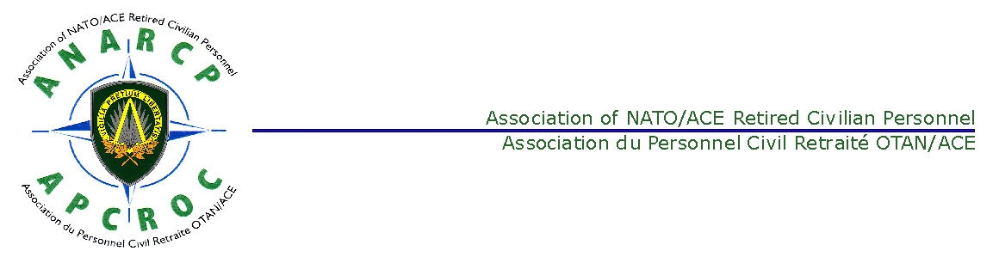
FINAL DRAFT
ANNUAL GENERAL ASSEMBLY (AGA)
MINUTES 22 MAY 2019

ITEM 1 - OPENING REMARKS AND ADMINISTRATIVE ANNOUNCEMENT
The Chairman welcomed all present, especially the guests, Major General Luis Lanchares (SPA A), Deputy Chief of Staff, STREN and ANARCP Patron and Colonel Hristov Radoslav (BUL A) representing Enrique Varona Bosque, Chief Civilian Personnel, Marco Controtti, Chairman of the SHAPE Civilian Staff Association (SCSA), and Olivier Guidetti, Chairman of NOBA and Mr. Gerard Malet, Chairman of ARO/ARNS. He also thanked all those who were presenting at the AGA.

2. AGA Attendees. A list of attendees is at Annex A.

3. Approval of the Agenda. The Agenda was approved.

4. Approval of the Minutes. The Minutes of the 2018 meeting was approved without change.

ITEM 2 - ADDRESS BY MAJOR GENERAL LUIS LANCHARES, ANARCP PATRON AND DCOS STREN
5. Major General Lanchares thanked the Chairman for the invitation for which he was honoured. He welcomed all present and emphasised how important retirees contribution had been to NATO and continues to be. He wished all a successful meeting and explained that Colonel Radoslav would brief the assembly on his behalf.

6. Major General Lanchares’s presentation is at Annex B.

ITEM 3 - PRESENTATION BY COLONEL RADOSLAV ON BEHALF OF ENRIQUE VARONA BOSQUE, CHIEF CIVILIAN PERSONNEL
7. The presentation is at Annex C.

ITEM 4 – PRESENTATION BY THE SHAPE CIVILIAN STAFF ASSOCIATION. (SCSA) – MR. MARCO CONTROTTI
8. Marco Controtti’s presentation is at Annex D.

ITEM 5 - NATREPS’ REPORTS
9. The NATReps reports are at Annex E. The ITA, NLD and TUR ANARCP NATReps provided their reports. Mr Jelle Batstra admitted that a recent communication between himself and the Assistant Secretary General on the subject of the linkages between the active staff and retiree pensions had affected the relation between the retirees and the active staff. Mr Enzo Arzeni stated that he believed that AAPOCAD should be involved in defending pensions rights. The overarching issue affecting the Association members currently is breaking the linkage between the active staff and the retirees pensions. Falko Bülling, stated that the enlarged CNRCSA EXCOM has decided to support the CNCSC decision on Active Staff decisions on the subject of health insurance
All NATRep reports are provided at Annex E.
Mr Hessel Rutten explained that the TUR issue on the subject of Supplement C is ongoing. This was currently the subject of an NATO Admin Tribunal (former appeals board).

ITEM 6 – PRESENTATION BY MRS ISABELLE TEZCAN CHAIR OF THE CNRCSA WG ON HEALTH ISSUES
10. Mrs Tezcan’s presentation is at Annex F. She emphasised the surveys carried out at the request of NATO HQ to cover ‘Primary Insurance’ and satisfaction. Mrs Tezcan responded to a question about UK National Health Service by responding that it was the retirees’ choice and decision as to whether they used UK NHS or similar national health services which do not offer a free choice of provider or used an alternative private facility.

ITEM 7 - ALLIANZ CARE PRESENTATION
11. The Allianz Care staff, Ms Yannik Brems and Dr Bojan Popadic provided their presentation and answered questions. Their presentation is at Annex G.

12. Mr Jelle Batstra commented that cancelling Supplement B could force retirees to use the national health system.

13. The term ‘Serious Illness’ is being reviewed by Allianz Care. After 40 years. A medical doctor has been employed to work on this issue. It has also been the subject of discussion in the JCB Working Group.
The Allianz Care staff commented that when Alzheimer’s is positively diagnosed then this is accepted as a ‘Serious Illness’.

14. The new Benefits Guide is due for publication in 2020.

15. Mr Gerard Malet commented that the Retirees’ Medical Claims Fund is growing and has increased in the last year by 6.5%. A study is being conducted into the sustainability of the fund, including demographics with a view to producing a new statistical projection.
Allianz staff commented that in order to conform with GDPR, a member would need to provide a consent form for their spouse to conduct claims etc. on their behalf.
Allianz assured the meeting that their systems are completely secure and cloud based.
Allianz Care staff commented that it is working on the possibility of providing in the future travel insurance, possibly in partnership with another insurance company.
The Allianz staff held a number of personal one to one consultations with ANARCP members.

ITEM 8 - REPORT ON THE CONFEDERATION OF NATO RETIRED CIVILIAN STAFF ASSOCIATIONS (CNRCSA)
16. Mr Hessel Rutten, CNRCSA Chairman, presented his report, which is at Annex H.

ITEM 9 – CHAIRMAN’S REPORT
17. The Chairman presented his report. The Chairman’s Report is at Annex I.
The Chairman also commented on the result of the nomination for EXCOM positions and indicated that there being two nominations for two EXCOM position, there had been no need for an election. Therefore, Mr Joergen Moeller and Mr Rik Loeckx would be members of the EXCOM. He noted that Mr Vanderwal will be the new Chairman and Mr Loeckx will be the Secretary.

ITEM 10 - TREASURER’S REPORT
18. The Treasurer presented his Report, the Financial Statement and the draft budget for the forthcoming year. The financial documents had previously been provided and was available on request. Mr. Delor indicated that the Association was in good financial condition. The Treasurer’s Report, Financial Statement and Budget are at Annex J.

ITEM 11 – PROPOSALS FOR MOTIONS
19. Mr Falko Bulling made the proposal detailed at Annex K which was passed by a show of hands. Mr Peter Ludford and Mr Laurie Daykin were appointed as Honorary President and Secretary respectively.
ITEM 13 - ANY OTHER BUSINESS
20. The Secretary informed the meeting that the status of the NATReps was enshrined in the ANARCP Constitution and Bye-Laws and that these would be reviewed and changes presented to the ANARCP members in May 2020. The proposed changes would take into account the change from ANARCP NATReps to CNRCSA Representatives.

21. There being no other business, the Chairman wished all attending a good lunch and a safe trip home.

ITEM 14 - NEXT MEETINGS
22. The date of the 2020 AGA is planned as 20 May 20 and will be confirm in the Summer 2019 ANARCP Bulletin.

Peter Ludford 23 May 2019
ANARCP Chairman

Annexes:
- List of Attendees
- Major General Luis Lanchares’s Presentation (ANARCP Patron), given by Colonel Hristov Radoslav
- J1 Presentation by Colonel Hristov Radoslav
- Presentation by Mr. Marco Controtti, the Chairman of the SCSA
- NATReps’ Reports
- Briefing by Mrs. Tezcan
- Allianz Presentation
- Report by Mr Rutten, Chairman CNRCSA.
- ANARCP Chairman’s Report
- Treasurer’s Report, Financial Statement and Draft Budget.
- Proposal for Motions
Annex A

AGA ATTENDANCE
SURNAME | First Name
ACAR | Suleyman
AMUNDSEN | Else-Marie
ARZENI. | Vincenzo
BATSTRA | Jelle
Colonel RADOSLAV (BUL A) | Hristov
BREMS (AWC) | Yannik (AWC)
BULLING | Falko
CHAMBERS | Geoffrey
CHAMBERS | Maggie
CLERBOIS | JEAN-PIERRE
CONTROTTI | Marco
DAYKIN | Laurie
DE COCK | Marie-José
DE VRIES | Victor
DE WINTER | Claude
DELOR | Jean
DEREDE | Nadine
DIERS | Jurgen
DIERS | Ailsa
DRAELANTS | Jo
DUVIVIER | Rosemarie
FLABAT | Roland
FRANKLIN | Lionel
FRANZREB | Gunter
FRANZREB | Sandra
FUSSHOELLER | Robert
GALL | Christine
GEN MAJOR LUIS LANCHARES | (ESP A) DCOS STREN
GIELENS | Theo en bep
GREGOIRE | Bill
GRUWEZ | Willy
GÜCER | Yiğit
GUIDETTI (CHAIRMAN OF NOBA) | Olivier
GUNGOR | Ismet
HAMMARGREN | Torstein
HUEY | Alan
HURLEY | Peter
LAITEM | Claude
LAMPE | Juergen
LEROY | Veronique
LOECKX | Rik
LUDFORD | Peter
MAAS | Herman
MAGGI | Arnaldo
MAGGI | Monique
MALET | Gerard
MINET | Michel
MOELLER | Joergen
NATHAN | Jan
NAWRAT | Josef
ORSTEN | Bård
PENNINCKX | Roland
POPADIC (AWC) | Bojan
RAIT | Denis
RIIS | Soren
ROBERTSON | Graham
RUTTEN | Hessel
SANDERS | Yves
SCHNEIDER | H. Helmut
SINDONI | Don
SMIT | Gwen
SMITS | Jack
STELANDRE | Annie
STEVENSON | Marc
TEZCAN | Isabelle
THORSEN | Gert Ladegaard
TIBERGHEIN | Godelieve
VAN DEN BROEK | Klaas
VAN 'T WOUT VON STADEN | Wilhelmina A
VANDERWAL | Jean
VELTRI | Franco
WALRAF | Marcel "Mike"
WALSCHAERTS | Robert
WARNIEZ | Michel
WILMES | Mrs
WOODCOCK | David
WOODCOCK | Sylvia
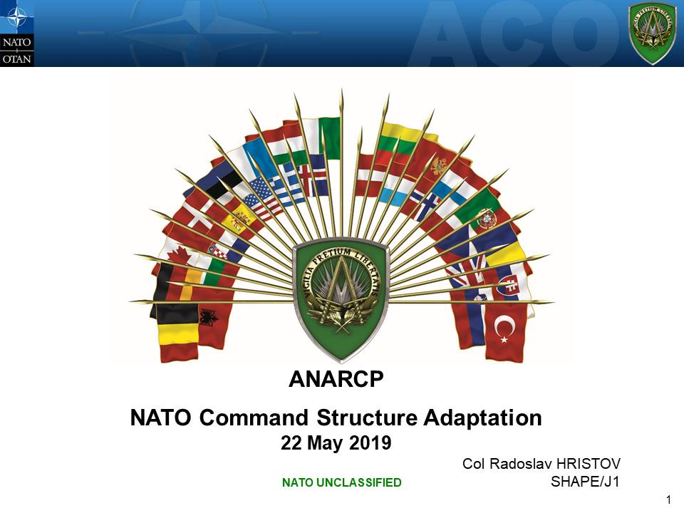
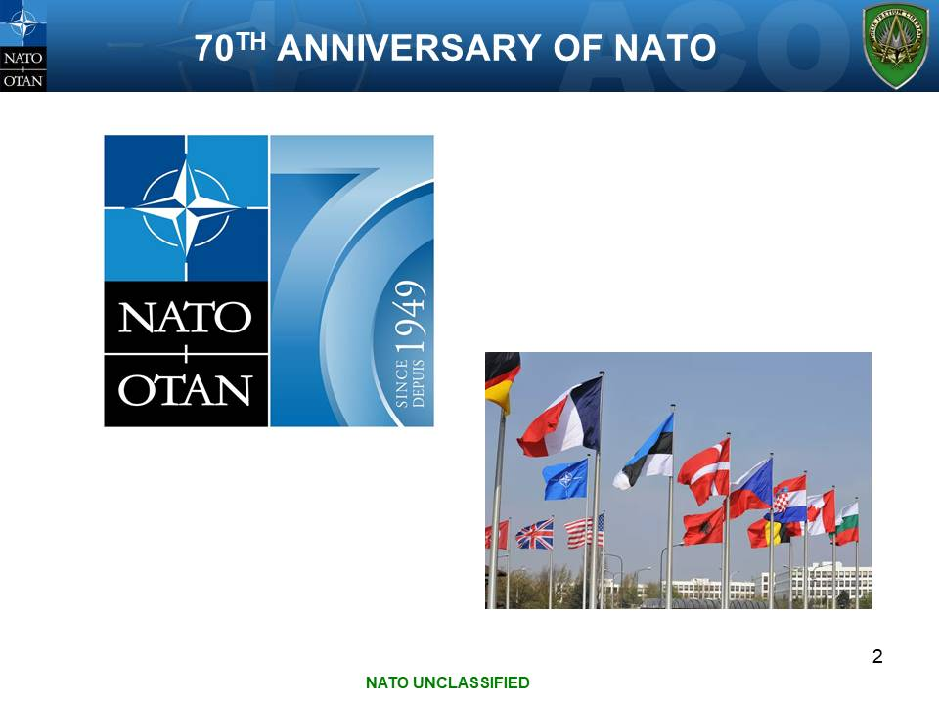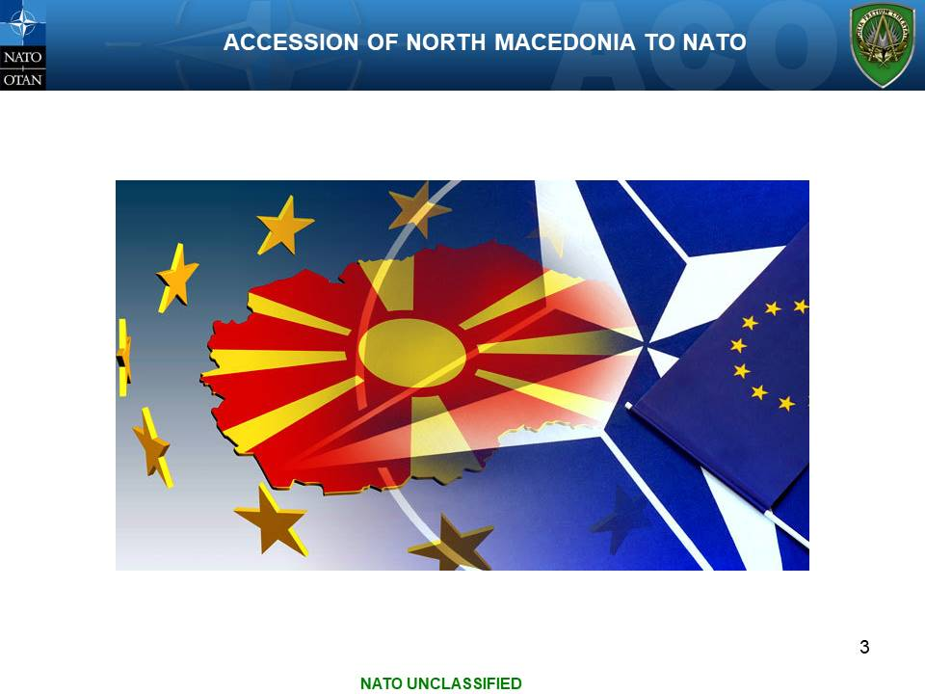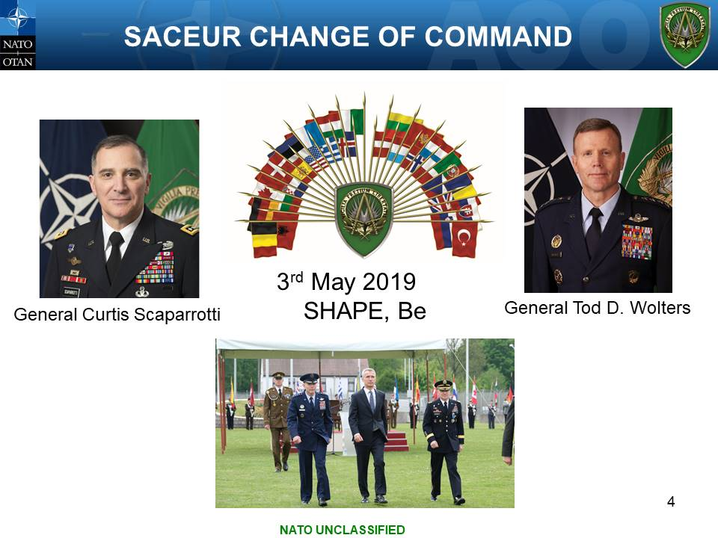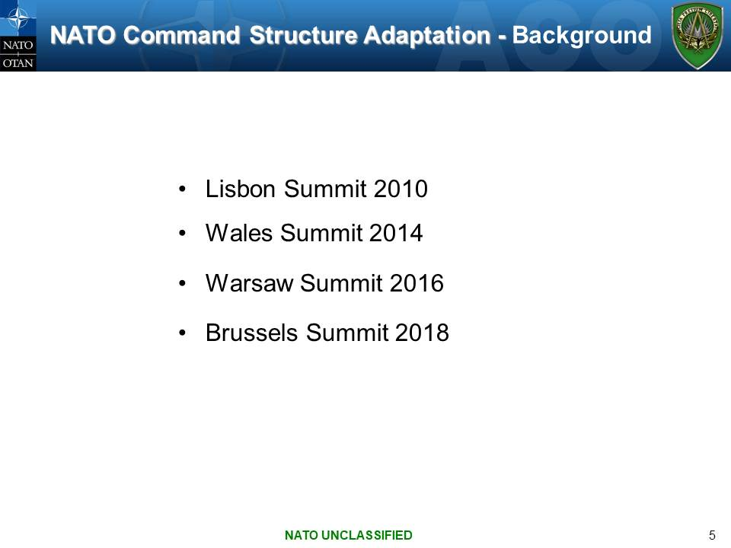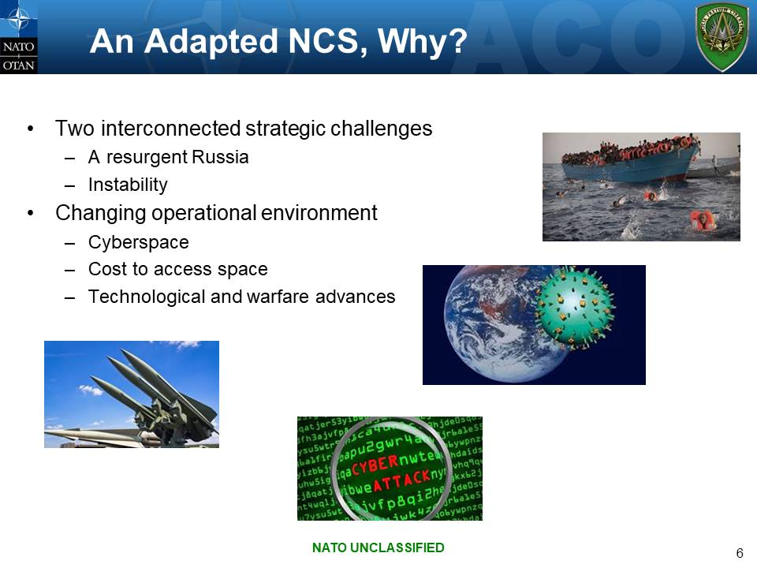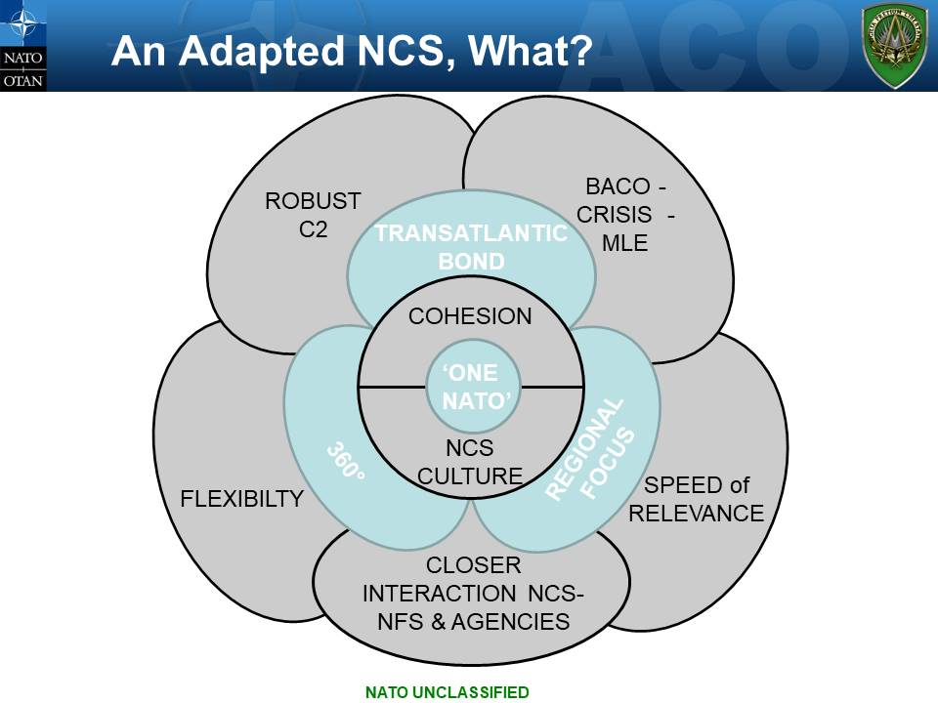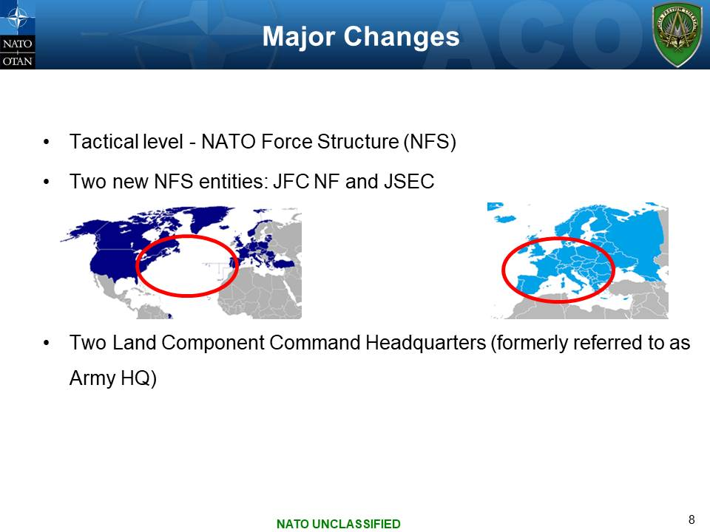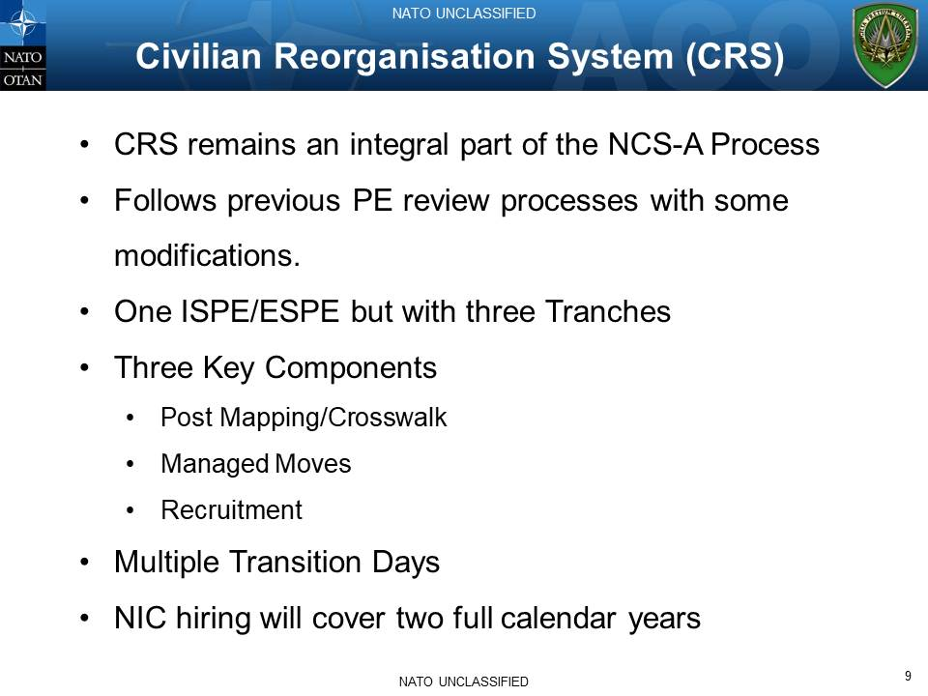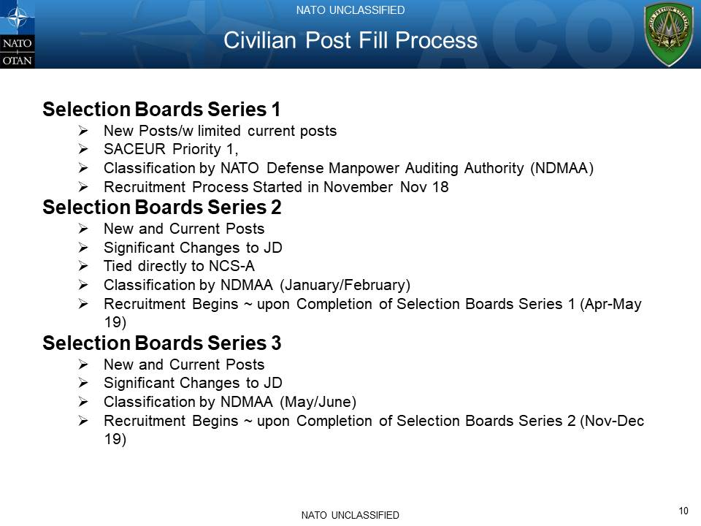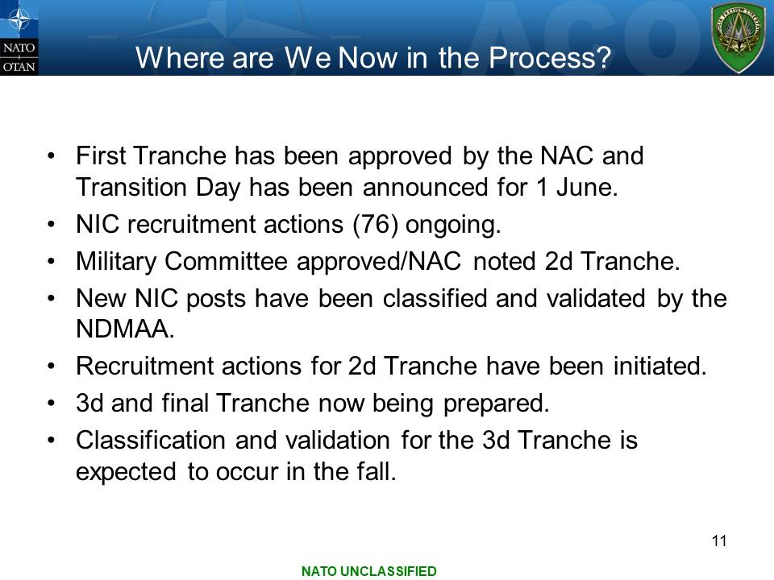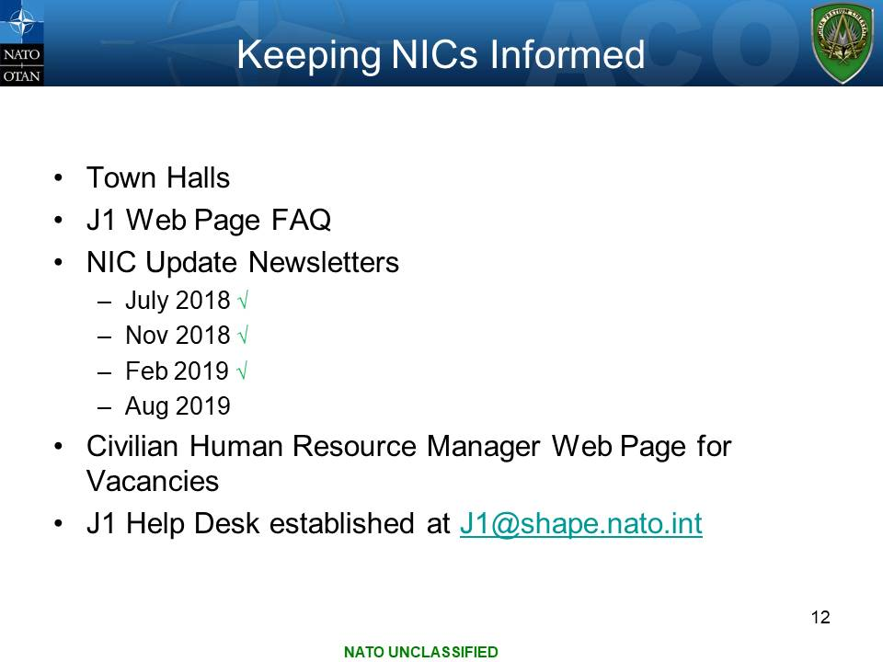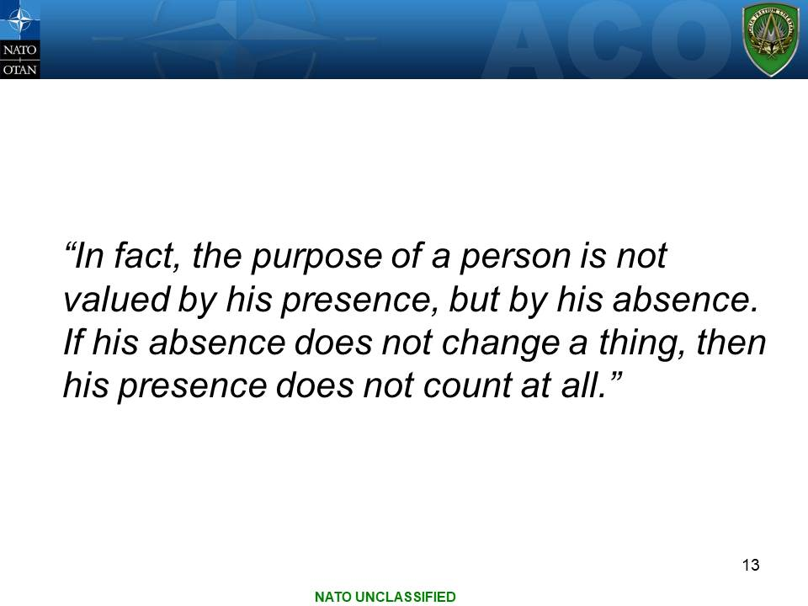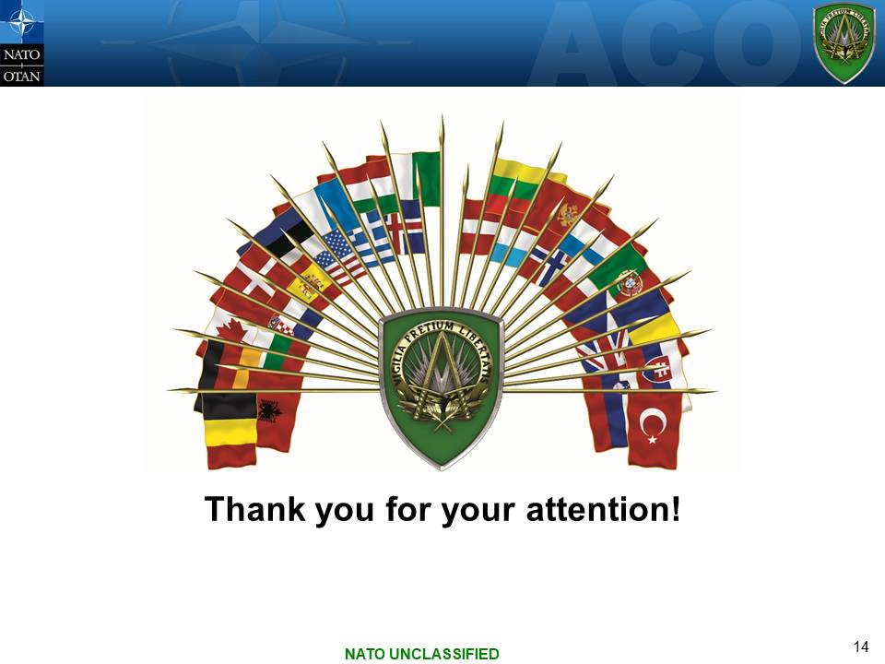
PRESENTATION
BY COLONEL RADOSLAV ON BEHALF OF DCOS STREN
Annex B
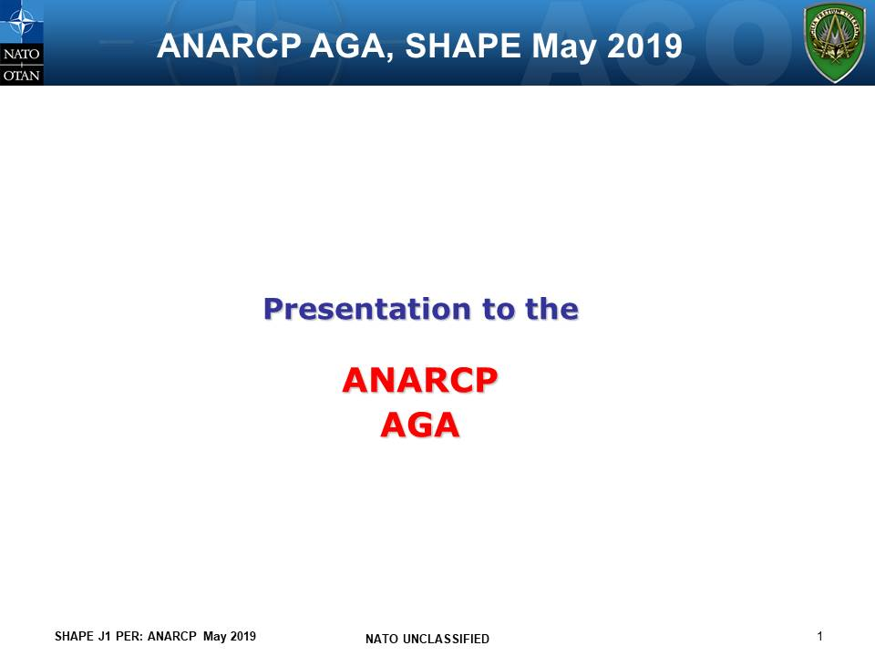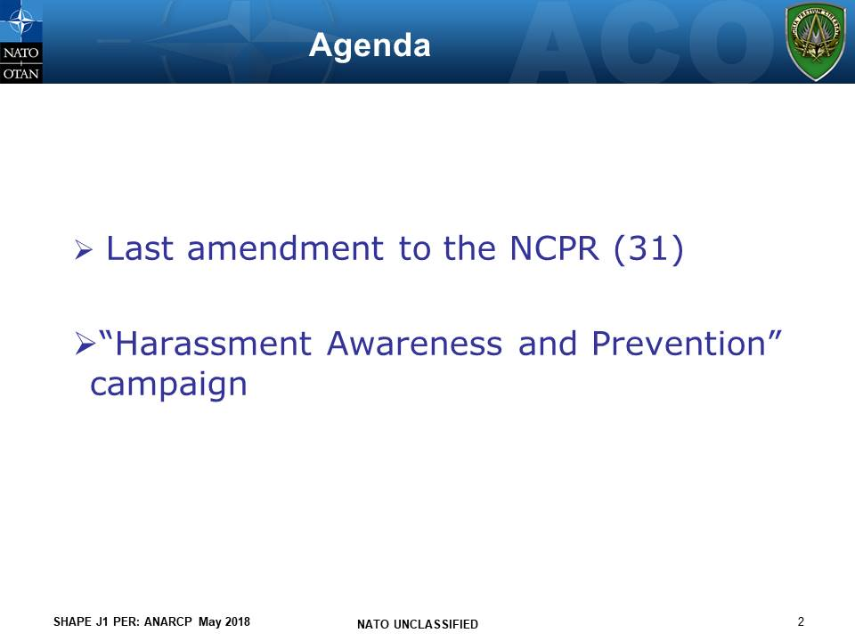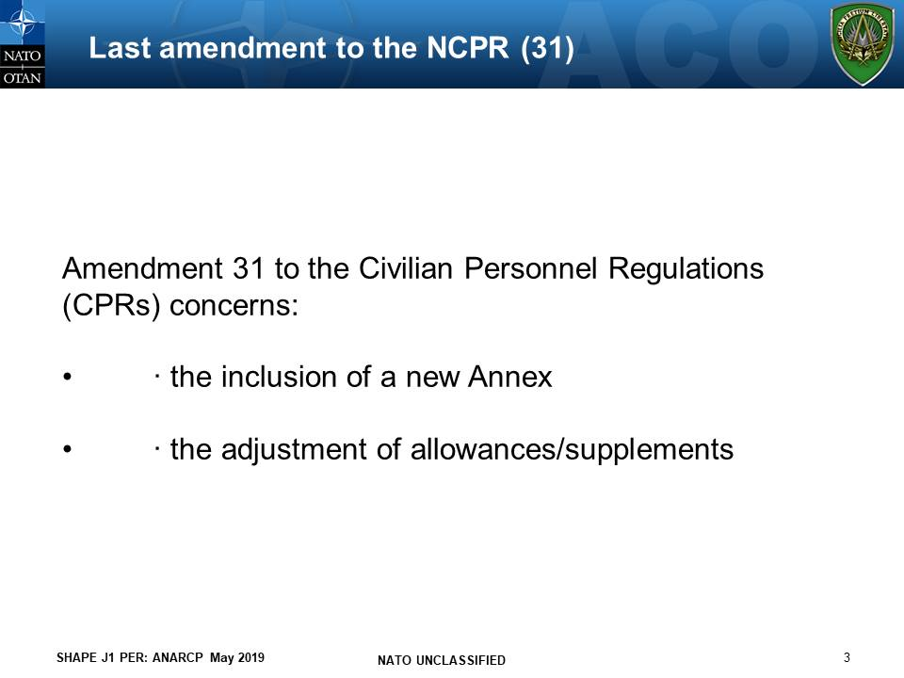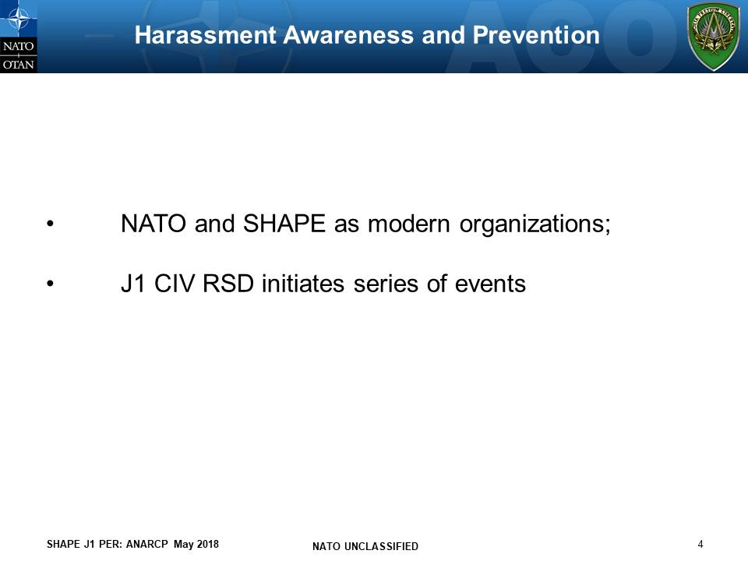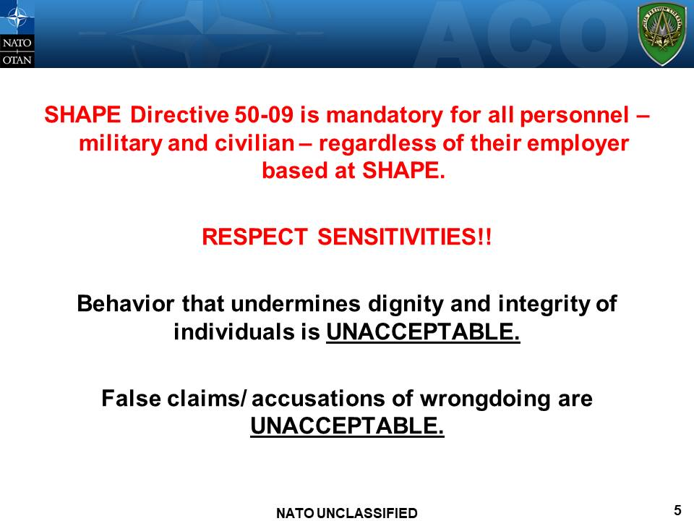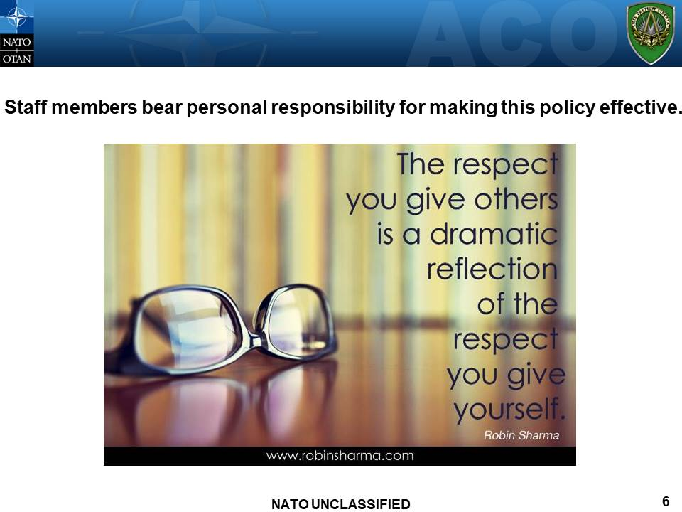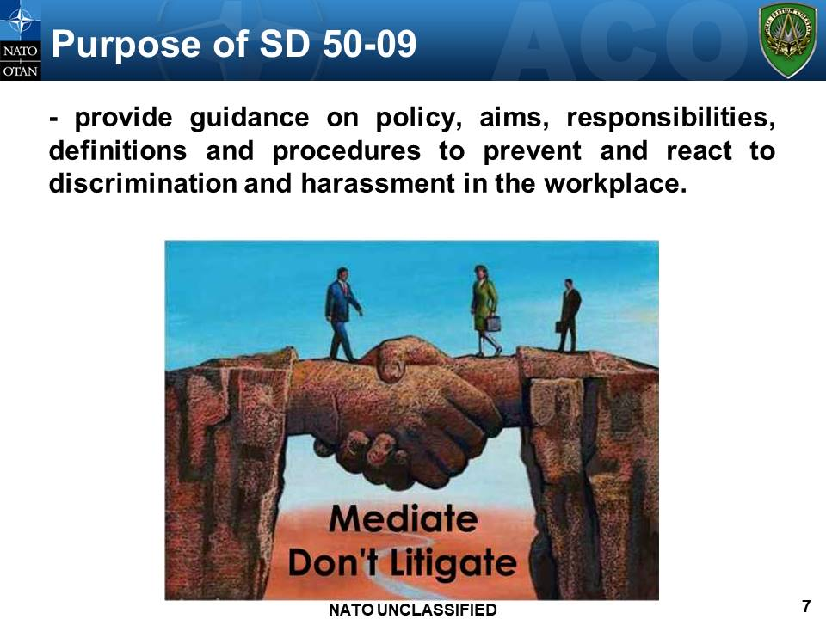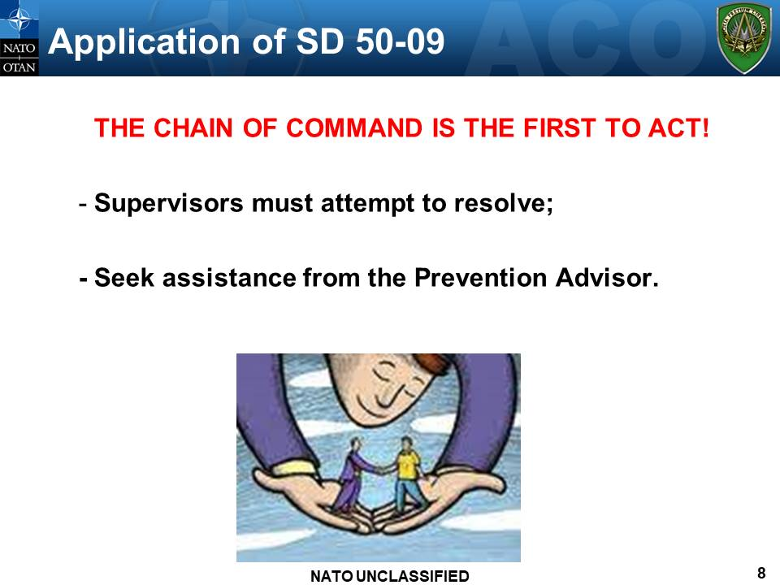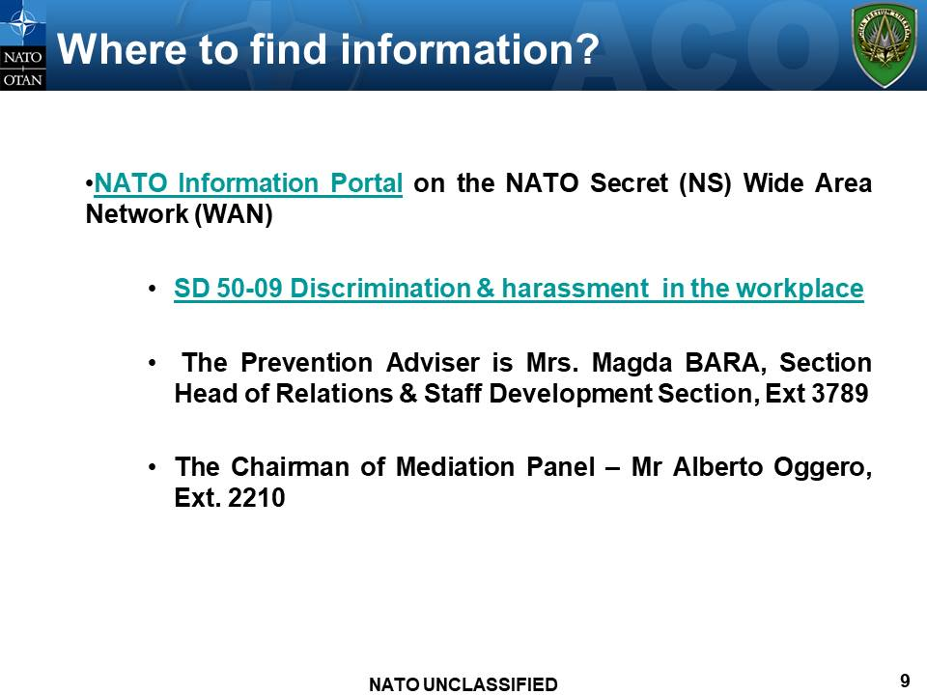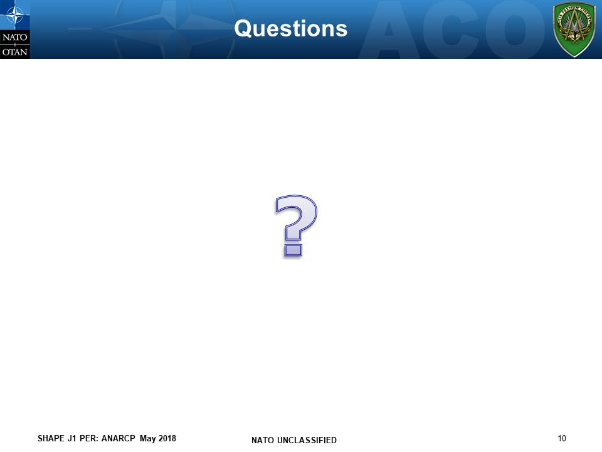
PRESENTATION
BY J1 BY COLONEL RADOSLAV
Annex C
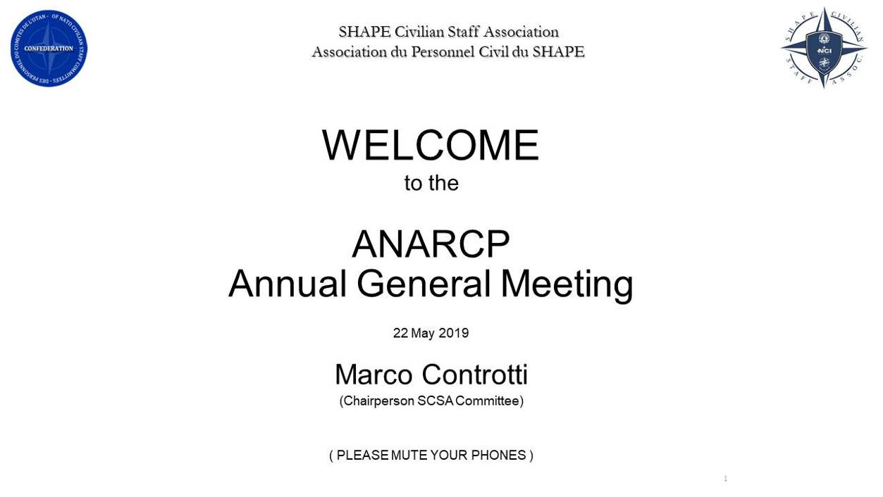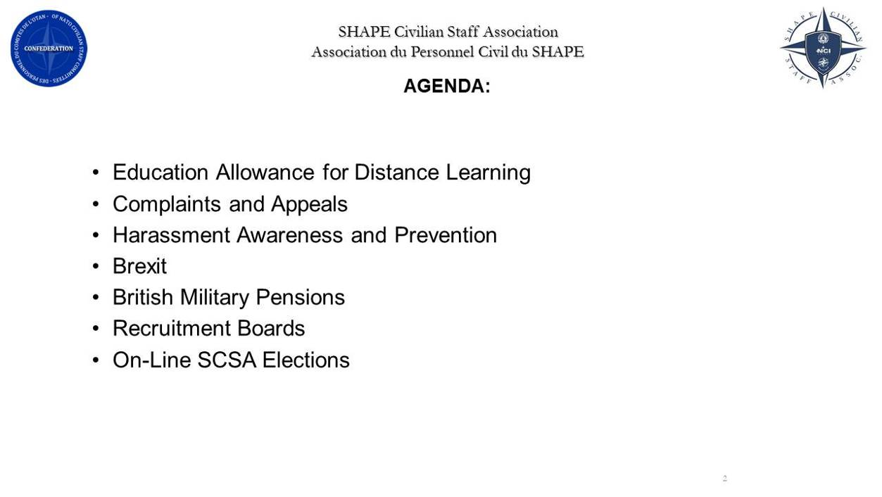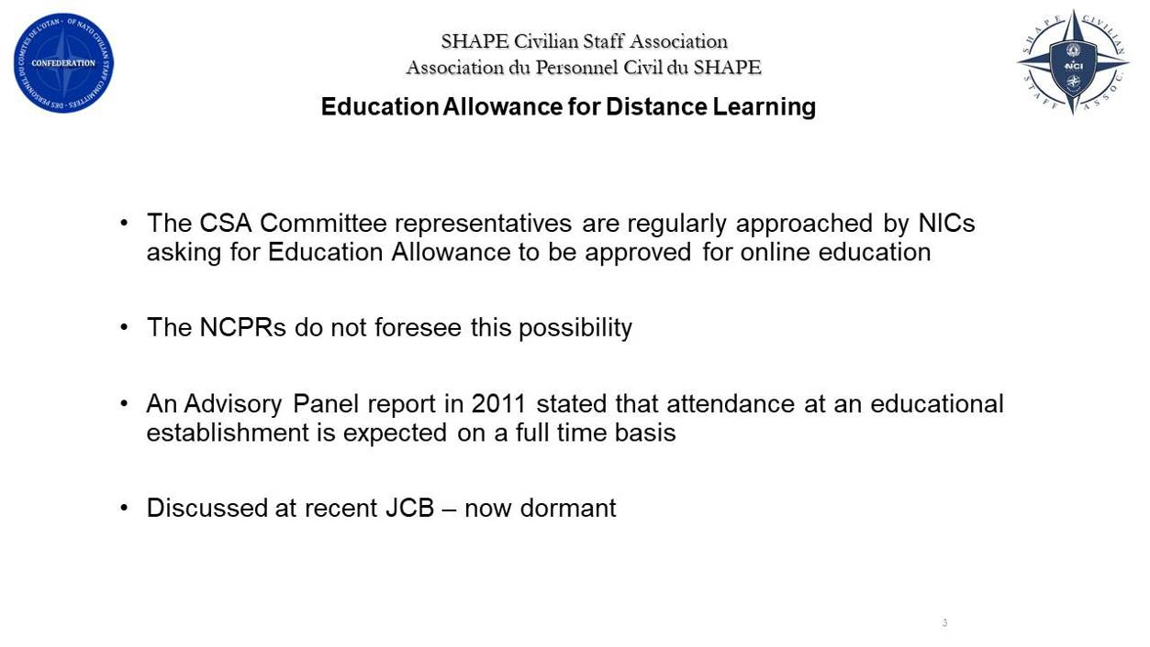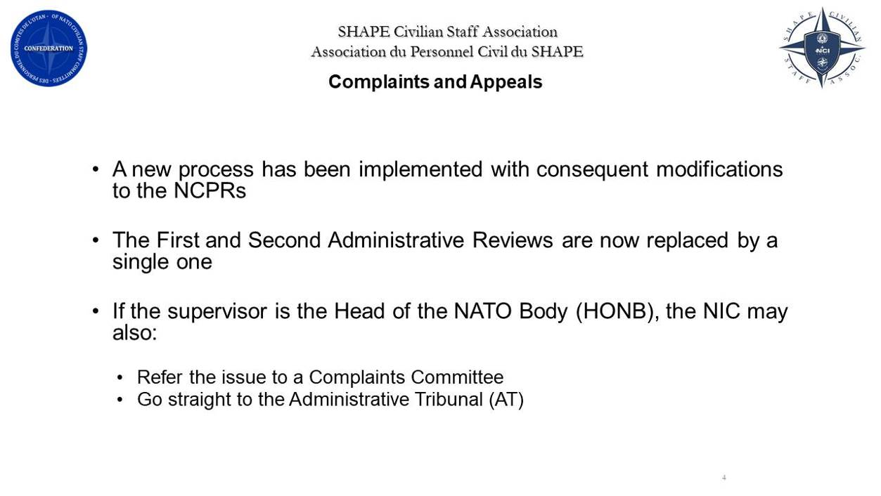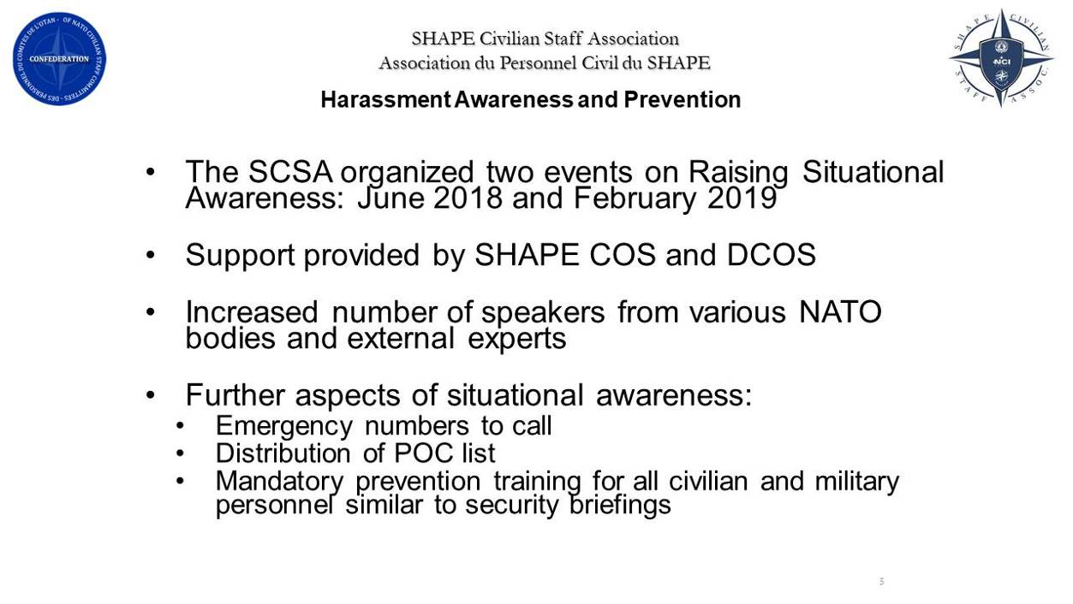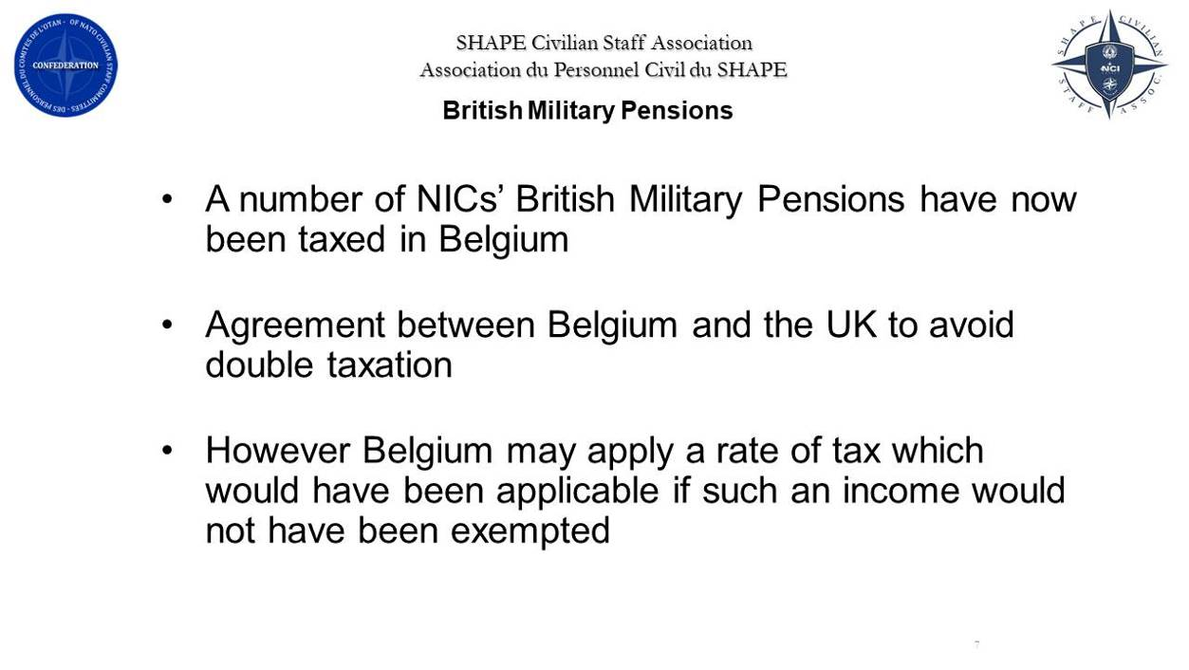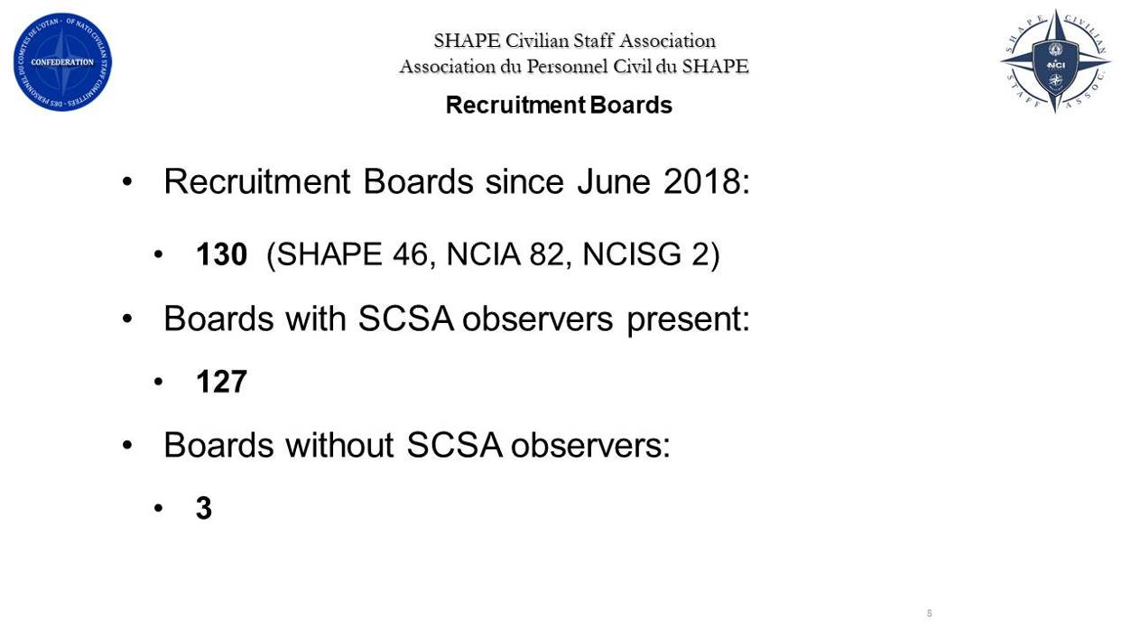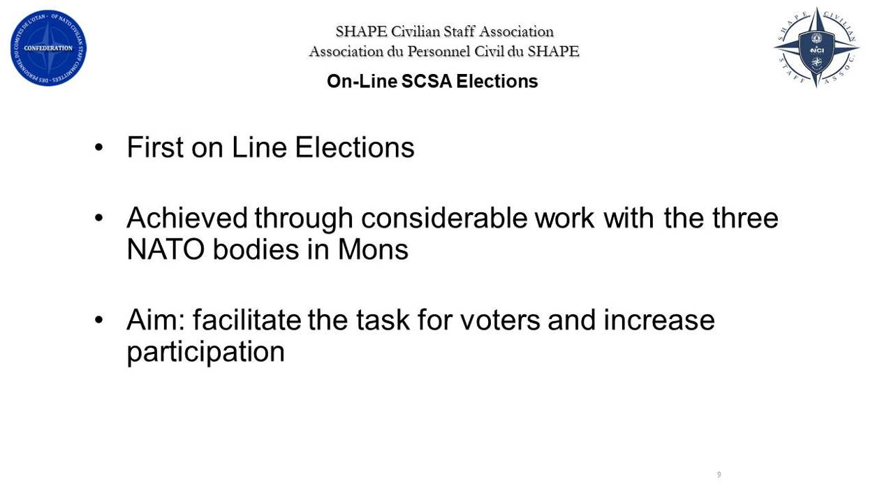
Annex D
PRESENTATION
BY MR MARCO CONTROTTI

Annex E

NATREPS’ REPORTS

BELGIUM

- Background/Intro:

NATREP BEL covers Belgium, Canada, Greece, Australia, and US.

Reps are myself and Yves Sanders.

- Personnel Issues

- Number of Members Life Members:

Total number of members: 250
Life members: 59 24%

- Number of Paying members:

Paying members: 191 76%
Auto-deduct 90 36%
Cash 101 40%

- Deceased Members:

Since May 2018, one deceased member: Mme Perone-Grillo who lived in Quebec

- Pension, Financial and Tax Issues:

One Canadian member with a serious tax problem, requested by Canadian authorities to pay back tax for a substantial period.

- NATO Health System (Allianz):

One member was told in 2016 by Pensions Unit he did not have to pay the medical coverage (CMC). Pensions Unit later (2018) requested him to pay up the backlog.
Mostly members are happy with Allianz.

- Social events:

An SCSA hosted event was held in January 2019 which was attended by most of the EXCOM and some members.

- The Future:

NATREPs to become CNRCSA delegates. Not yet clear how that will work.

DENMARK

- Personnel Issues

- Number of Members Life Members: 2

- Number of Paying members: 18

- Deceased Members:1

- Other Personnel Issues and Problems: NTR

- Pension, Financial and Tax Issues: Domestic Bank fee introduced. Issue not solved. Tax adjustment reduced for 2018. Excellent justified by ISRP in Paris (Tax pressure reduced in DNK)

- NATO Health System (Allianz): NTR

- Social events: Combined social and information meeting executed 19 August. 14 members participated.

- The Future: Hard to say, but we as a group are not growing. What is the minimum numbers to continue to have a permanent representative?

TURKEY
- Background/Introduction:
We had to continue to deal with three major issues in the past one year period:
a. The first issue concerns the reinstatement of our Supplement C coverage of the NATO Group Health Insurance Contract. It took most of our time with a tremendous amount of correspondence with NATO IS and CNRCSA.
b. The second issue concerns a special pension adjustment that was not granted in the second half of 2018. We have been wrestling with AAPOCAD, (the Association of Pensioned Staff of Coordinated Organizations and of their Dependants. and the ISRP (the International Service for Remunerations and Pensions of OECD) and NATO International Staff to correct a mistake in the implementation of Annex II, Article 7 of the NATO Civilian Personnel Regulations. ,
A Special Adjustment due as of 1 July 2018 was not implemented and pushed forward to 1 January 2019 as a result of ISRP’s reluctance to accept that the price index increase threshold of 7% had been breached for Turkey in the last four months of the Reference Period 2017-2018. Thus, unjustly, 6 months' salary arrears for staff and pensioners in Turkey have to date not been paid.
c. Finally, our proposal to reduce the threshold for Special Adjustments of salaries and pensions to 3%, as it was in the past, and to eliminate the inflation watch period of two months has been disregarded and put aside by the CRP and CRSG for, as far as we know, another two years. I will provide further information on these three issues in just a moment.

- Personnel Issues:
a. Number of Life Members: 15
b. Number of Paying Members: 68
c. Deceased Members: 4
d. Other Personnel Issues and Problems:
We have not had any other personnel issues or problems in the past one year period.

- Pension, Financial and Tax Issues:
We have two pension-related issues that both concern Special Adjustments against the current high inflation trend in Turkey.
- Non-payment of 6 months’ arrears for the period 1 July – 31 December 2018:
The current NATO Civilian Personnel Regulations (CPRs) Annex II Article 7 provides for the reimbursement of Special Adjustments to serving and retired staff every time the increase in the Harmonized Index of Consumer Price (HICP) index exceeds a threshold of 7% within a given Reference Period (1 July of year n to 1 July of year n+1). However, the HICP increase for the two following consecutive months must remain greater than 7% for the adjustment to take effect.
The HICP increase for Turkey as recorded by the International Service for Remunerations and Pensions (ISRP) of OECD reached 7.6% in the eight months from 1 July 2017 to 28 February 2018 and a Special Adjustment of 7% became due with effect from 1 March 2018. Since inflation continued to remain greater than 7% in the two following months, March and April, the ISRP drafted and the Coordinating Committee on Remunerations (CCR) approved a Special Adjustment with effect from 1 March 2018.
Subsequently, the increase in the HICP Index in Turkey from 1 March to 30 June 2018 reached 7.3% and inflation continued to exceed 7% in July and August. However, ISRP has not drafted a Special Adjustment report since early September 2018 and CCR have not sent an approved report to NATO.
We have strived to ensure the preparation of the report through our representation within AAPOCAD and the Committee of the Representatives of Personnel (CRP) at Coordination Level since September of last year. However, ISRP insisted that the threshold had not been breached in their explanations to CRP and NATO IS and we were advised by AAPOCAD to resolve the matter with NATO.
I, together with our AAPOCAD Regional Delegate for Turkey along with an odd 25 pensioners sent letters to NATO IS in early March 2019 requesting the payment of the six months’ Special Adjustment arrears of 7% for the period 1 July – 31 December 2018. No result was forthcoming from the CRSG/CRP Coordination meetings held in late 2018 and in early 2019. Our AAPOCAD Regional Delegate for Turkey has written to NATO IS Deputy Assistant Secretary General (DASG) for Human Resources asking for the resolution of this issue and we are still waiting for an answer concerning NATO’s position.

- Proposal to reduce the Special Adjustment threshold in the NATO Civilian Personnel Regulations from 7% to 3%, and eliminate the two-month inflation watch period:
As mentioned above, the current NATO Civilian Personnel Regulations (CPRs) Annex II Article 7 provides for the granting of Special Adjustments to serving and retired staff to counter the effects of high inflation every time the Harmonized Index of Consumer Prices (HICP) exceeds a threshold of 7% within a given Reference Period (1 July of year n to 1 July of year n+1). However, the HICPs for the following consecutive 2 months must remain greater than 7% for the adjustment to take effect.
Prior to 2012 the Special Adjustment threshold was 5% and even lower in earlier periods (3%). Additionally, the entire increase in the consumer prices index would be granted, whereas since 1 January 2017, only 7% (the threshold) is being granted after the additional two-month inflation monitoring period, with the introduction of the current Coordinated Organizations Remuneration Adjustment Method.
In October 2018, our AAPOCAD Regional Delegate submitted a proposal for reducing the threshold for Special Adjustments back to its previous value of 3% along with the elimination of the two-month inflation monitoring period. Accordingly, it was also requested that the entire amount of the consumer price increase be applied to pensions every time the threshold would be breached.
However, the Committee of the Representatives of the Secretaries General (CRSG) whose Chairman is NATO IS Deputy Assistant Secretary General (DASG) HR, submitted to the Coordinating Committee on Remunerations (CCR) their proposal not to make any changes to the current Coordinated Organizations Remuneration Adjustment Method for another two years after the current method expires at the end of 2020.
This proposal, if agreed to at Coordination level, would mean no changes could be introduced to the Adjustment Method through the end of 2022.
We believe the requirement for reducing the Special Adjustment threshold must nonetheless be considered as a requirement warranting an imminent solution given the high inflation prevailing in Turkey. We would like NATO IS to support our request as an ad hoc change to the method through the efforts of Chairman, CRSG.
- NATO Group Health Insurance System (Allianz):
Under this heading, we have the long ongoing issue of the illegal rescinding of Supplement C to the NATO Group Insurance Contract (NGIC), which concerns the reduction of claim reimbursements for out-patient treatment expenditures in Turkey from 100% to 90%.
Rescinding of Supplement C:
Supplement C to the NATO Group Insurance Contract (NGIC), instituted some 30 years ago upon the request of civilian staff serving at the NATO military headquarters in Izmir, Turkey in accordance with CPRs Article 47.1(e) foresaw the full reimbursement of out-patient medical treatment expenses incurred within Turkey.
An overwhelming majority of the serving staff opted for this supplementary insurance and paid additional premiums. After a certain date, retiring staff who signed for the continuation of Supplement C continued to pay premiums as well after they left the Organization.
NATO IS rescinded Supplement C as of 1 January 2018 based on an informal request from the Civilian Staff Association of the serving staff in Izmir. By that date the number of insured retirees had far exceeded that of serving staff and the retirees were not notified of the action taken by NATO IS.
The Delegation for Turkey of the CNRCSA (the Confederation of Retired Civilian Staff Associations) strived to object to this unilateral action from early February 2018 through February 2019.
On 6 February 2018, an odd 35 retired staff members sent letters to NATO IS EM to request the undoing of the rescinding of Supplement C. Following several attempts by us to rectify the lost right, NATO IS belatedly completed the Administrative Review on the matter and rejected our plea in April 2018.
The whole period from our follow-up correspondence in May through August was lost as no positive response was forthcoming from NATO IS HR. In August 2018, as the CNRCSA Delegate for Turkey, I applied to NATO Secretary General for the matter to be resolved at the NATO Administrative Tribunal. The response from NATO IS HR advised that we had to apply to the Complaints Committee, but that they had no intention to let us to pursue a Complaints procedure. I then applied for a second time for the issue to be resolved at Administrative Tribunal (AT) level. Finally, on 11 April 2019, NATO Deputy Secretary General sent a letter advising us that we may apply to the AT.
In coordination with ANARCP that provided us with the necessary funding and with the guidance of Chairman, CNRCSA, we were able to find an excellent legal counsel to defend our case at the Administrative Tribunal. Our appeal petition was submitted by my Legal Counsel to the AT on 8 April. We will be eagerly following the developments at the AT very closely through our Legal Counsel. If deemed necessary, I will participate in the hearings.
- Social events:
We were not able to organize any social events due to the past one year period being our initial year in the job. Moreover, we had to spend an excessive amount of time to keep up with the developments concerning the very important issues that I explained above. However, we plan to organize a dinner event in October or shortly before the New Year.
- The Future:
The purchasing power of NATO salaries and pensions in Turkey has eroded by more than 50% during the past 10-year period due to a continuing high inflation and the drawbacks of the Remuneration Adjustment Method in redressing the purchasing power losses.
A study paper was prepared by the Civilian Staff Association (CSA) Staff Committee of Headquarters Land Command Izmir. This analysis showed an overall loss of 65% in purchasing power.
Since this is a matter that concerns NATO personnel and retirees in Izmir, Turkey and NATO is the only Coordinated Organization employing personnel in Turkey, it was decided that looking for a solution to our purchasing power erosion problem within NATO would be a better approach. The CSA of HQ Land Command has already submitted a proposal to NATO IS and the issue will be discussed. We will continue to work closely with the CSA on this issue in order to bring about a meaningful improvement in the Turkish salary scales.
On behalf of the retired members of staff in the Turkish region, I would like to reiterate my appreciation to Chairman, ANARCP and Chairman, CNRCSA and their work associates for the their generous support and constant advice throughout the period since our last Annual General Meeting. I wish to convey the heartfelt thanks of all ANARCP members in my region for your solidarity which will be dearly needed in the face of the difficult challenges to be overcome in the months ahead.

FRANCE

Background/Intro:
My name is Günter Franzreb, I am of German Nationality. I am the National Representative for the French Region since 2011. I retired in 2004 from INFOSEC Command, SHAPE, after nearly 35 years of service. This is my 8th year as the French Rep and my 7th address to the ANARCP General Assembly.
My Deputy is Graham Robertson of British Nationality.
We cooperate well and keep each other up-to-date. He is always ready to stand in for me.
I would like to finish the short introduction by thanking the Chairman and the whole Executive Committee for their work, time and dedication they have given to our Association during the past year on our behalf. Without them we would not be able to function.
On a personal note: I wish Peter, who is not putting forward his nomination for the new Executive Committee of ANARCP, all the best for the future and thank him for the excellent job he has done on our behalf. Peter was always available and to give advice. I have appreciated his cooperation and friendship over many, many years and I shall personally miss him very much. Thank you Peter on behalf of the French Region.
I have not been made aware of any specific issues to be raised for the French Region, it seems that everyone is sailing along happily.

Personnel Issues:

- Number of Life Members: 14

- Number of Paying members: 19

- Number of Deceased Members: 1

- Other Personnel Issues and Problems: I have the pleasure to announce the arrival of a new member to the French Region, Mrs Karen Bishop. She has retired in January 2019 from SHAPE and has settled down in the Paris region.

- Pension, Financial and Tax Issues: None

- NATO Health System (AWC): None

- Social events: None

- Other Issues: None

THE UNITED KINGDOM

There are currently 118 ANARCP members in the UK chapter. This includes retirees living in Cyprus (2), Portugal (3) and Spain (8). In addition there is one member listed as resident in Barbados. We currently have 39 Life Members and 17 that do not have email. All other members are now paying their annual fees by Automatic Deduction.

Sadly two members of the ANARCP have passed-on since our last meeting these are:

• Mrs llone Rowell
• Mr Peter Keam Condolences were sent to the families of both members on behalf of the ANARCP and I personally attended the funeral for Peter Keam.

Fortunately 2018/19 has been a very quiet and unremarkable year during which any issues involving me as National Representative have been of a routine nature for example: Information, Advice and guidance.

Consequently, there is nothing of overall importance or significance to bring to the attention of either the ANARCP Plenary or AGA.

In my capacity as the UK Regional Delegate to the Confederation, I have some responsibility for a further 113 members from NATO HQ and 12 from NAMSA Luxembourg.

Finally, we have not had any social activity during the past year.

D M Rait UK National Representative

ITALY

Background/Intro:
Mr. Chairman, ladies, gentlemen, good afternoon. My name is Vincenzo Arzeni, Enzo for you, and I am the NatRep for Italy.

Personnel Issues

Number of Members Life Members: 84
Number of Paying members: 28
Deceased Members: 0
Other Personnel Issues and Problems:
The decision to eliminate the meeting of the Nat Rep should be reopened.

Pension, Financial and Tax Issues:
The analysis of the results of the salary adjustment procedures in the period 2010-2019 shows that in two of the NATO major countries (Italy and Spain) the salary levels in 2019 are
practically the same of those in 2010, All the others countries considered had an increment above 11% with a special situation in UK were the increase was 30%.This difference is due to the purchasing power parity corrections that is positive for the
majority of the countries considered while it is very negative for Spain and Italy. Taking into account the high impact of this corrections it will be advisable to do a survey to verify if the data used for the calculations are reflecting the real situation of the staff of the coordinated organization employed in Italy and Spain. Mr. Chairman I ask your support in requesting the CNRCSA Chairman to represent our concern to the AAPOCAD/ISRP.
Recently we have been asked from AAPOCAD to sign the petition against the idea of the CCR that the adjustment of our pension benefits should no longer be aligned with the salary adjustments of serving staff. We have done it, but this request aroused a lot of concern among the Former Staff Members belonging to the Pension Scheme.
Related to the pension benefit, is its taxation. In the AAPOCAD Bulletin n. 62 we read the lecture given by Laure Levi, Lawyer at the Brussels bar. I want to just refer to her conclusion on the tax subject : … if the Coordinate Organizations (CO) wan to guarantee the equal treatment to their officials, whether serving or retired, then they cannot rely on the tax system of their Member countries ….the doctrine and the case-law agree in their consideration that the pension is a form of deferred salary. This being the case, the same legal regime must apply to both.
Mr. Chairman, I would like to see an action of AAPOCAD, in relation to this lecture, towards the CO to defend our pension right. With the support of the other NatRep, I ask you to represent this principle to the CNRCSA Chairman.
Thank you Mr. Chairman.
NATO Health System (Allianz):
The latest survey on other insurance caused a lot of concern among the NATO retires. I tried to let them understanding that nothing is changed, but the use of the National Health System, where possible, prolongs the life of the RMCF and our life as well.

Social events:
We had a social event during the Christmas time, but the number of participants is getting shorter and shorter.

The Future:
The ANARCP must exist as it is.

This conclude my report, thank you Mr. Chairman.

THE NETHERLANDS

Personnel Issues
The number of NATO pensioners in The Netherlands has had a small increase over the last year. In 2017 we had a total of 380 pensioners, 335 ANARCP, 25 ARO members and 10 NOBA pensioners. this year we have 380 pensioners in total, of which 25 are ARO members, and 10 are NOBA members.
Some 50 members have not given an authorization for automatic deduction from their pension or are in the Provident Fund and have to pay their contribution on request.
Over the period February 2018 – March 2019, we were informed that 8 ANARCP members died.
NATO Group insurance Contract
A major concern arose when we were informed that the confederation of the Active Staff, after its June meeting in Amsterdam, had written to the NATO management requesting cancellation of all Supplementary policies except Supplement A, in order to harmonize the Health Insurances for all countries.
The conditions of Supplement B were negotiated in the 1960’s as the basic NATO Health Insurance did not provide the same cover available in The Netherlands, which was also a condition to obtain exemption from participation in the Dutch National system.
The retirees in The Netherlands are strongly opposed to this request, as supplement B provides 100% cover for specialist care and medication, which for many cases otherwise only would be reimbursed for 90 %, and which could lead to very high cost
I have expressed our concern to the NATO Management, by writing a letter to ASG Patrice Billaud-Durand and indicated that continuation of the important elements of Supplement B are of an upmost importance for the retiree community in The Netherlands. Although I have mentioned this problem on several occasions to the Chair of the Staff Association of NCIA, I got little support from the NCIA Staff Association. The active staff seems not to be aware of the problems that might arise.
The issue has been discussed in Advisory Panel and a JCB Working Group meetings, and the NATO legal office has been tasked to look in the legal aspects of this issue. No further news is available at this time.
One item of uncertainty keeps worrying the retiree community : How will the NGIC support the insured persons if someone has to be taken into a nursing home. This issue cropped up a number of times, and had to do with members of our community who had to be taken to a nursing home because of mental and or physical problems. In general AWC has been very helpful in finding solutions, but the uncertainty when one has to handle under difficult emotional conditions, where large amounts of money might be involved, causes much enormous strain for those involved.
This problems mainly occurrs because of incompatibilities between the Dutch Health Insurance system and the way in which AWC operates.
No further major issues were reported in relation to the NATO Group Insurance contract. Some minor issues cropped up, but they were all solved in a good cooperation with AWC.
Taxation
Another important issue in The Netherlands is related to the taxation of the NATO pensions. In 2012, a large number of NATO pensioners, who made an official complaint against their pensions being fully taxed as income, have been offered a compromise by the Dutch Tax authorities. In this compromise 1/3 of the pension can be taxed as property and 2/3 can be taxed as “normal” income. This way of taxation of the pension can result in considerable reduction of the taxes to be paid.
From 2017 onwards, a large number of NATO retirees who filed a complaint as from 2010, were offered a similar compromise. Although the compromise offer gives no justification to the special position of the NATO retiree community, it is accepted by most pensioners.
For those that did not file a complaint, and for retirees with an invalidity pension and for some pensioners that retired after 2010, pensions are still fully taxed as income. This results in a difference of treatment, which is unacceptable as all NATO retirees retire under identical conditions.
The same income tax regime applies to retirees from the European Space Agency in The Netherlands. AAPOCAD, representing the pensioner organizations of NATO and ESA, together with the Administrations of NATO and ESA, have had discussions with the Dutch Tax Authorities. Allthough the impression was given that the discussions were to be continued in 2018, no further meetings were scheduled.
Distribution of information
During 2018 and 2019 2 information bulletins were distributed to the ANARCP members.
Annual Meeting of ANARCP in The Netherlands.
The Annual information meeting for ANARCP members was held on 15 March 2019 in the conference facilities of NCIA in The Hague. The meeting was attended by some 70 members.
Isabelle Tezcan briefed the meeting on the ongoing discussions with NATO PSS and AWC.
AWC was represented by Dr. Bojan Popadic as IGO Operations Manager and by Mrs Yannik Brems, as Client Relationship Manager.
Social Event.
After the meeting a lunch was arranged in which some 60 ANRCP members participated.

NORWAY
Background/Intro: ANARCP Norway is located in Oslo and holds its annual meetings at the old AFNorth HQ at Kolsås.
Personnel Issues:
- Number of Members who are Life Members:
We have 15 Life Members.
- Number of Paying members:
The number of paying members are in two categories:
Provident Fund 4
Auto deduction 21
Total member base is 40
- Deceased Member: Bjørn Åge Brauten member no: 1437
NATO Heath System (AWC):
Social events:
The annual membership gathering took place on Monday 13 May 19. We had 26 attendees – 18 members and 8 dependents. The agenda had 3 items:
To meet old friends and enjoy coffee and cakes together.
Go through and update the members list.
Information to members, including questions and answers.
After the coffee and cakes, we had a discussion of a problem with bank charges. Some of our members have been deducted expenses by their bank when receiving their monthly pension. The deduction is in most cases NOK 100 for every transfer, and they have the same problem when receiving reimbursement of medical claims from AWC. The case have been brought up with some of the banks, and they tell us it has to do with the expense code used on the transfer by the sender.
The Pension unit has been made aware of our problem and has told us we will be reimbursed once a year in Feb if we provide a yearly justification.
We have booked time with AWC at the AGA and hope to discuss this with them at the meeting.
Finally, we had a long discussion on election of a new No NAT rep and a deputy No NAT rep. We managed to find two members who was willing to step into these positions, and their names will be forwarded when it has been formalized.
This concludes the NO NAT rep report.

Torstein Hammargren
Deputy NO NAT Rep.

Annex F
BRIEFING BY MRS TEZCAN
HEATH INSURANCE WORKING GROUP PRESENTATION

ALLIANZ SURVEYS
The Primary Insurance Survey was sent to affiliates during the second week of May. As announced earlier, its purpose is to update the Allianz database to make sure that all persons insured - (retired) staff and dependents - have declared whether they have a primary (national of private) insurance, in which case they have to claim reimbursement from that source first, if applicable.

I. Tezcan has obtained assurances that the survey was sent not only electronically but also by mail to unconnected affiliates. It appears from a check that not all retirees present received the survey. Allianz is asked to check again their emailing databases.

I. Tezcan has learnt from the Head, Insurances, International Staff (IS) that comprehension problems have arisen among both staff and administrators concerning the purpose of this survey. It appears from the reactions of the audience that indeed and in spite of repeated explanations retirees residing in some countries do not understand that nothing has changed.

A clarification will be sent by the Administration to ensure the proper implementation of the survey. As a consequence, it has been decided to postpone the Customer Satisfaction Survey.

SERIOUS ILLNESSES
Both Confederations’ working groups dealing with health insurances have started a new joint initiative aiming at updating the list and clarifying the criteria for recognition of a serious illness (e.g. Alzheimer and dementia). A medical consultant has been hired in order to assist the WGs in this project. Head Insurance has been informed of this initiative and welcomed it. The current plan is to present this project at the next JCB WG meeting to be scheduled in autumn.

HARMONIZATION
The decision taken by the Active Staff Confederation to harmonize the supplementary cover by way of cancelling all « national » Supplements was discussed in the JCB WG in November 2018. Following a heated discussion including legal arguments, and in the absence of a representative from the Office of the Legal Adviser (OLA), the IS was tasked to develop a roadmap to make progress on this issue.

I. Tezcan, supported by F. Bulling, explains once again that the Retired Staff Confederation has been supportive of the Supplementary Insurance harmonization, which is both a cost containment measure and a protective measure for small (retired) staff communities where even one very serious case cannot be easily absorbed by the remaining members. The Confederation understands that some retiree groups (in particular in the Netherlands) may not be happy with it, but the Confederation has a responsibility towards the whole retiree community and solidarity is its overarching principle.

Concerning the way ahead, due to the appeal lodged by Turkish retirees against the rescinding of their Supplement on 1 January 2018, it seems improbable that the IS will proceed further on this issue in the short term.

BENEFIT GUIDE
The last distributed BG is dated 1 January 2016. No change was made to the benefits since then. Slight changes were made to the Tables of Benefits as far as ceilings are concerned. The current ToB may be consulted online. As the publication of the BF and ToB have a cost, it has been agreed with Head Insurances that for the moment being there would be no new paper edition.

Annex G

PRESENTATION BY ALLIANZ CARE

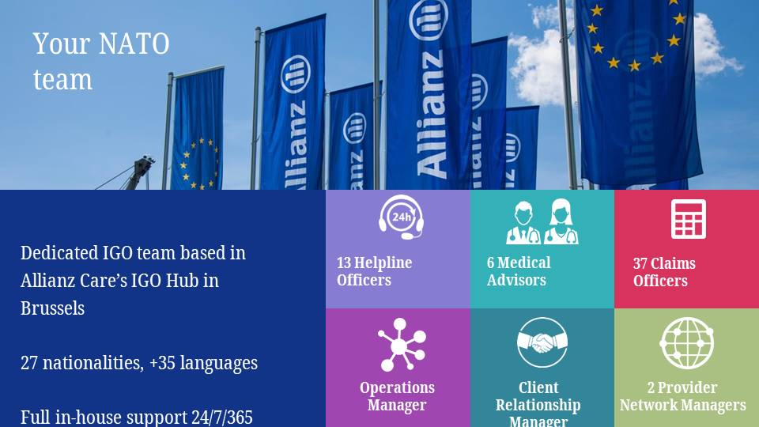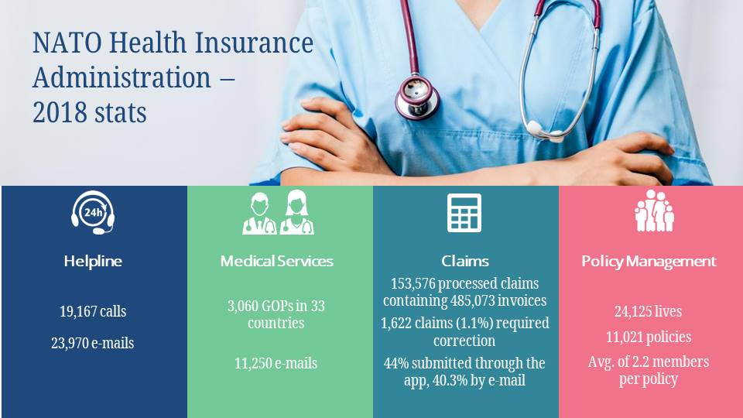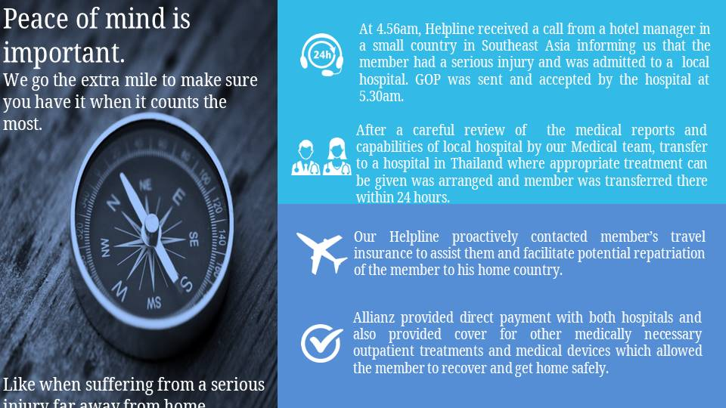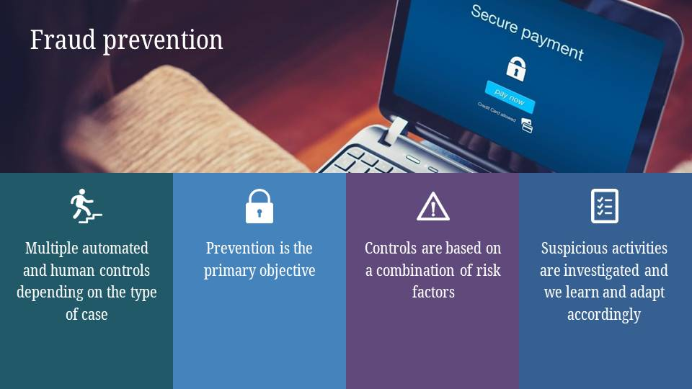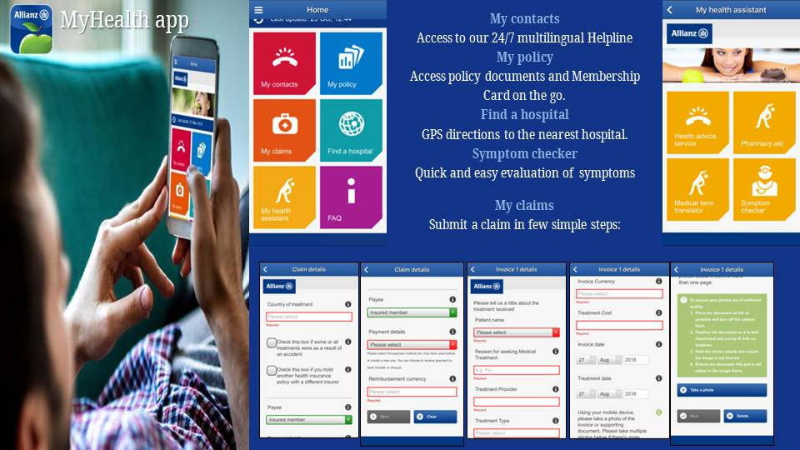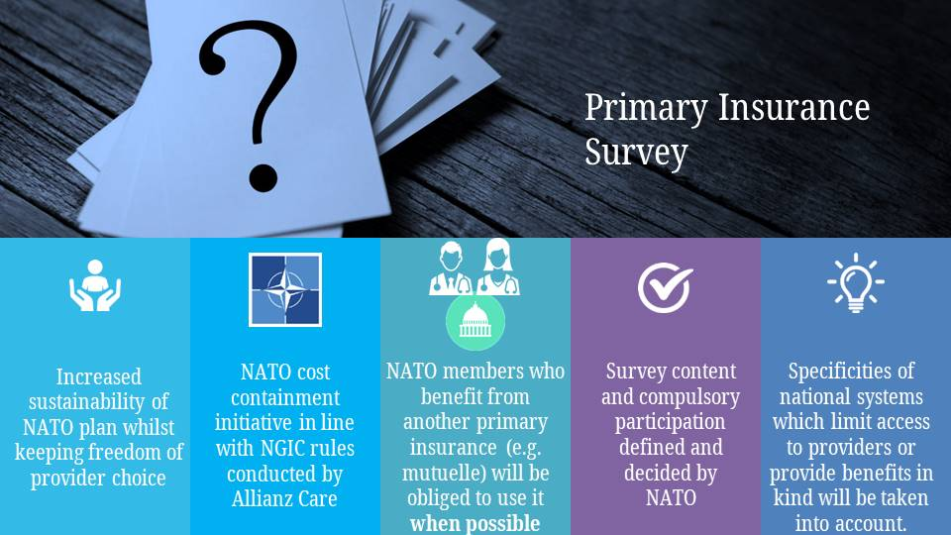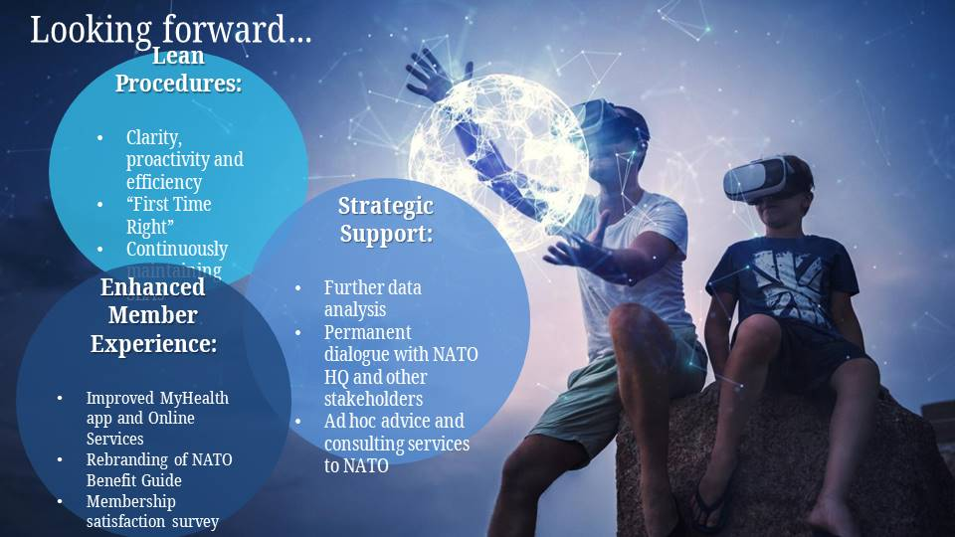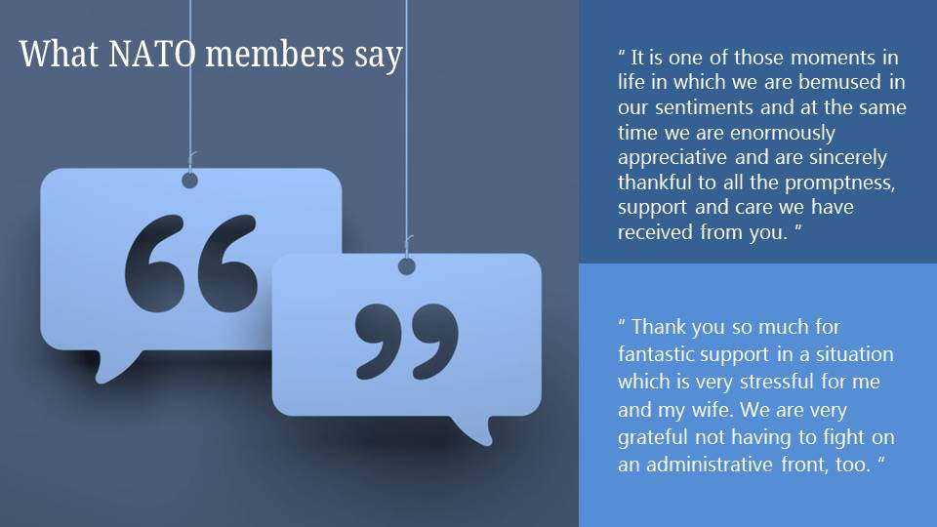

Annex H
MR HESSEL RUTTEN
CHAIRMAN CNRCSA

Times have changed. The status of pensioners no longer automatically follows that of the active staff if the CCR gets what it wants. Major challenge. Strong action to be taken; CRP meeting Monday and Tuesday; AAPOCAD Thursday and Friday in Koblenz

Petition to be signed separately by AAPOCAD members and other pensioners. No double signatures; to be discusssed later

Role Confederation vs ANARCP vs AAPOCAD; Decisions are taken in CRP and in JCB where Confederation represented; ANARCP not, only through Confederation. Newsletter of January adressed most issues

History current CCR proposal: last years all allowances were reviewed, everything went down for actives but no effect on pensioners as result of vested rights. For instance: expat allowance: less salary after 5 year service, impossible in any system but not with CO’s;
Salary adjustment 3year system now with moderation clause : 2% bandwith no problem as long as salaryincrease is below 2% (next year problem also because of pension contr. from 9.5 to 12.1%

Nothing left for nations to change but our COPS
Legal opinion that because of vested rights only raising pensionable age could be taken into account by CCR LA/ vice chair.
However, CCR tasked CRSG to come with proposals otherwise unilateral action. This spring CRSG paper with 2 proposals to treat pensioners different from actives. Idea to sepate pensioners from actives comes from new salary scale for Lux where 2 Nations objected to apply the scale to pens. . Raising pensionable age not pursued by CRSG: 3 pro, 3 CO against. CRSG came with proposal to separate with only OECD against. NATO not, according to paper; Sec Gen and ASG Bush said differently. Effect:1. education allow. affects 75 CO pens. of which 25 NATO ;2. art 36 pension rules,to be changed so that purchasing power parities would guide pension review. Art 36 is the fundament of the pension rules; vested rights, (paper by G Palmieri) separate approval cycle in seventies in each CO specific for provident funders that were guaranteed the tie between salary and pension . Effect : if purchasing power parities introduced in past effect minus 10%. Result can be: Affordability clause could be used for pens. but not for actives. Opens the door for any other different treatment of pensioners.
This week in CRP decision on industrial action; petition AAPOCAD. CCR beginning July in Paris very important

Other issues discussed in the past and inNewsletter:
Complaints and appeals
art 51.2 CPR appeal by valerie Laurita ,RMCF
TU suppl C supported only by ANARCP
DCPS and 3rd pension scheme
SSS + LUX and HU B&C scales
Registered partnership
Annex I
ANARCP CHAIRMAN’S REPORT 2019

It gives me pleasure in presenting this 2019 Chairman’s report but with some sadness because this will be my last report to you. I will cover the detail briefly before turning to the current state of our Association and my views on the future.

Currently, we have 1142 members, which is a drop of 17 on last year. There are two reasons for this, one of which is obvious, the deaths of almost 30 of our members. But the main reason is that we suspended over 30 members due to non-payment of the annual membership dues for 2017. I don’t know how the new EXCOM will approach this task but it is important that members pay their Dues and for this we require work and cooperation of all ANARCP NATReps. I have appreciated their cooperation.

NATReps To Regional Delegates. For several years I have stated that the Confederation is transitioning to a new comprehensive structure for the 4 Retiree Associations and I have cautioned that the Confederation needs to act to bring this about. For the 3rd time I will state the importance to the Confederation of clear lines of Communication, Command and Control and transitional arrangements that leave the Regional Delegates confident that they are useful, welcome and supported by the Confederation. I have a message for the Confederation, be in no doubt, without the Regional Delegates support, the Confederation cannot properly function. I will also say that in my opinion, Regional Delegate’s Deputies are vital for the proper function of the Confederation.

Elections for the ANARCP Executive Committee. This year we have two nominations for the ANARCP Executive Committee. You will know both Michele Vrydag and I are standing down and two new members will take their place on the committee, they are Joergen Moeller and Rik Loeckx. I welcome Joergen and Rik to the committee and wish them well; I am sure that they will be an asset. It is up to the Executive Committee to decide who fills which role and the EXCOM will meet after this AGA.

AWC. I would like to mention the service provided by Allianz Care. I recall 10 years ago that there was considerable disquiet amongst the retirees about the poor service provided by AWC as it was then. Compare this to the current situation. I believe Allianz Care deserves due recognition and praise for the turnaround. From my experience, they are quick to settle claims, responsive and take due care of the retirees. Perhaps an example of this care is the private meetings we have at this AGA between our members and Allianz.

Thanks. I would like to thank you, the Retirees, for supporting me and the Committee, without cooperative retirees our job is so much more difficult. The National Representatives for their cooperation and hard work.

Now to the Future. With my time as Chairman drawing to a close, I can only express an opinion and, in the future, advise caution and encourage. But I will say only a few words about our Association and your Executive Committee. To the members I would say please don’t fight the transition to a Confederation structure. It is inevitable. That is the only way for the issues that you as Retirees will face, to be addressed effectively and successfully, from a position of collective strength and with a united front. Of course, there will continue to be individual and personal problems to which we must attend but the bigger issues that affect all retirees can only be tackled in Brussels from a policy and sometimes political level. The recent attack on our pension system by delinking our pensions from the salary adjustments of serving staff is a case in point. No individual Association has the means to fight this on its own. As a final request I ask the ANARCP National Representatives for their cooperation and support for the new Chairman and the Chairman of the Confederation to achieve their goals.

Finally, I would like to thank all of you for coming to support this Annual General Assembly. We have more members attending this year and one or two prospective members here today. I have confidence that ANARCP Executive Committee will work tirelessly on your behalf. Most of the work may be unseen but it is essential for the good of its individual members and the whole organisation.

Annex J

ANARCP Budget 2019
BUDGET 2019 |  |  | in euro
EXPENDITURES
POSTAGE |  |  | 100,00
STATIONARY |  |  | 150,00
ADP ALLOWANCE |  |  | 700,00
AGA/DINNER + EXEC |  |  | 6,200,00
TRAVEL |  |  | 5,000,00
BANK CHARGES |  |  | 50,00
NAT REP ACTIVITIES (5€ per member) |  |  | 1,200,00
FLOWERS FUNERAL/PRESENT |  |  | 250,00
WEB SITE |  |  | 80,00
TEL. NATREP |  |  | 50,00
Contribution to Confed. (2€ per member) |  |  | 2,400,00
TU appeal |  |  | 5,000,00
Miscellaneous/Reserve |  |  | 3,220,00
 |  |  | 24,400,00
INCOME
FEES (950 X 20) |  |  | 19,000,00
AGA/DINNER |  |  | 1,800,00
TRAVEL |  |  | 3,500,00
INTEREST EARNED |  |  | 100,00
 |  |  | 24,400,00
NET RESULT |  |  | 0,00
Yearly contribution amounts to to 20 €.
JED 08/05/2019

ANARCP
FINANCIAL STATEMENT PER 31.12.2018 |  |  |  | in euro |  |  | Budget 2018
(From 01.01.18 until 31.12.18)
EXPENDITURES
POSTAGE |  |  |  |  | 14,25 |  | 100
ADP Allowance |  |  |  |  | 700,00 |  | 750
STATIONARY |  |  |  |  | 24,00 |  | 150
BANK CHARGES |  |  |  |  | 39,20 |  | 50
FLOWERS FUNERALS |  |  |  |  | 181,25 |  | 150
WEBSITE |  |  |  |  | 73,81 |  | 150
TEL NATREP |  |  |  |  | 0,00 |  | 50
TRAVEL |  |  |  |  | 2,838,00 |  | 5000
LOCAL ACTIVITIES (Nat rep) |  |  |  |  | 1,004,25 |  | 1000
GENERAL ASSEMBLY + Exec Cottee |  |  |  |  | 5,037,70 |  | 6200
Contribution to Confed, (2€ per member) |  |  |  |  | 2,288,00 |  | 2400
Contribution to new WEB Site CNRCSA |  |  |  |  | 0,00 |  | 1000
Miscellaneous |  |  |  |  | 0,00 |  | 7800
 |  |  |  |  |  | 12,200,46 | 24800
INCOME
FEES MEMBERSHIP |  |  |  |  | 17,284,00 |  | 19000
2016: 15 €
2017: 199 €
2018 received from NATO: 12.660 €
2018 balance: 3.485 €
2019: 925 €
TRAVEL 2017 |  |  |  |  | 4,979,86 |  | 4000
INTERESTS (32,96+58,99+0,50) |  |  |  |  | 92,45 |  | 0
DINNER G A |  |  |  |  | 1,665,00 |  | 1800
 |  |  |  |  |  | 24,021,31 | 24800
NET RESULT |  |  |  |  |  | 11,820,85
RECONCILIATION ASSETS/ACCOUNTING
BANK per 01.01.18 |  |  |  |  | 14,691,14
SAVINGS per 01.01.18 |  |  |  |  | 102,228,33
 |  |  |  |  |  | 116,919,47
INCOME |  |  |  |  |  | 24,021,31
EXPENDITURES |  |  |  |  |  | 12,200,46
 |  |  |  |  |  | 128,740,32
BANK per 31.12.2018 |  |  |  |  | 26,419,54
SAVINGS per 31.12.2018 |  |  |  |  | 102,320,78
 |  |  |  |  |  | 128,740,32
DIFFERENCE |  |  |  |  |  | 0,00
J.E.D.
12-01-19

Annex K
Proposal for a Motion
By Mr Falko Bulling
Dear ANARCP members,
We all know Peter Ludford as the ANARCP Chairman who for many years has exercised his steady, unflappable influence over our proceedings. He has steered the ANARCP ship through stormy seas and some difficult periods. We are exceptionally grateful for his contribution and sound council, both to the ANARCP organisation and to individual members who he has helped over the years.

Also Laurie Daykin has been Secretary for six years and through his energy, initiative and forthright approach has transformed the way that ANARCP carries out its work. He has supported the ANARCP, the Chairman and the EXCOM with unstinting loyalty and dedication and for that, we are exceptionally grateful.

Both Peter and Laurie wish to continue to support the ANARCP Members and the Executive Committee.

The Executive Committee therefore Proposes that a Motion be passed appointing Peter and Laurie as Honourary President and Secretary respectively. They will have a non-executive status within ANARCP but their services, to advise help and support the Executive Committee will be invaluable in the future and they may, if invited, attend the EXCOM Meetings in an advisory capacity.

